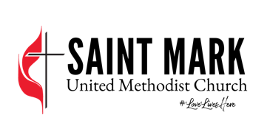

2901 Columbiana Road
Vestavia Hills, AL 35216

Privileged to Serve, Privileged to Give
Pledge Form for 2023

“Each of you must give as you have made up your mind,
not reluctantly or under compulsion, for God loves a cheerful giver.” - 2 Cor. 9:7

First Name(s):______________________________________ Last Name:______________________________

E-mail: _______________________________@________________________________________

General Fund Commitment - pays staff salaries, church operations, programming, and missions

My pledge to support the General Fund of Saint Mark United Methodist Church during 2023 is:

Amount: $______________________Per: (Circle One) Week Month Year

Payment Method: (Circle One) Recurring Bank Recurring Vanco Check/Cash
For help setting up a recurring payment call: 205-907-0009

Capital Fund Commitment – pays the mortgage and capital improvements of the church property
My pledge to support the Capital Fund of Saint Mark United Methodist Church during 2023 is:

Amount: $______________________Per: (Circle One) Week Month Year

Payment Method: (Circle One) Recurring Bank Recurring Vanco Check/Cash
For help setting up a recurring payment call Deanna: 205-907-0009

Three Ways to Pledge:
- Return this form by mail: Saint Mark UMC, 2901 Columbiana Road, Vestavia Hills, AL 35216
- Pledge online: https://saintmarkumc.org/stewardship-2023/
- Return this form in person: Commitment Sunday at Saint Mark, Sunday, October 23

~For where your treasure is, there your heart will be also. Matthew 6:21

